How to remove Middle Name initials in Excel

In Excel, if you're analyzing or processing a dataset and the middle name initials are not relevant to the task at hand, removing them can help streamline your analysis and make it easier to work with the data. When presenting data or creating reports, you may choose to omit middle name initials to maintain a cleaner and more concise format. This can be particularly useful when you have limited space or want to improve readability.

The dataset provides information on seven individuals along with their phone models, net worth, car models, and company names. The individuals' names are listed in Column A, where each name includes a middle name initial. In Column B, simplified names without middle name initials will be written by following the methods presented in this tutorial.

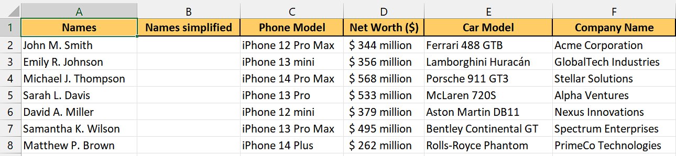

## Method 1 – By using Find and Replace tool

## Step 1 – Selecting the Range of cells

* Select the Range of cells containing the names from which you want to remove the middle initials.
* For instance, we have selected the range (**A2:A8**).



## Step 2 – Opening the Find and Replace Tool

* Go to the **"Home" tab** in the Excel ribbon.
* Click on the **"Find & Select" button** in the **"Editing" group.**
* Then **select** **"Replace"** from the **drop-down menu.**
* **Alternatively,** you can use the **keyboard shortcut "Ctrl + H"** to open the **Find and Replace dialog box** directly.
* After doing that, **Find** **and Replace tool** will **appear** on your screen.



## Step 3 – Removing the Middle Name initials

* After the dialogue box has opened, **enter** **space,** **asterisk (*) and a space again** in the **"Find what" field.** Just like this **( * ).**
* Then, simply **enter a space** in the **“Replace with”** **field.**
* Now, click on **Replace All option** and all **Middle Name initials** will be **removed** from **names** in **selected range of cells.**
* Then **close** the **Find and Replace tool.**



## Method 2 – By using Function created in VBA

## Step 1 – Adding a module

* Open your Excel workbook.
* **Press "Alt + F11"** to open the Visual Basic Editor.
* In the **Project Explorer window,** locate and **select the workbook** where **you want to** **add the module.**
* **Right-click on the workbook** name and select **"Insert" from the context menu.**
* **Choose "Module"** from the options.
* This will **insert a new module** in the project.
* **Double-click** on the **newly created module** to open it in the **code editor.**



## Step 2 – Writing the code

* **Copy and paste the VBA code below** into the module.

Function Rmv_mid_init(name As String) As String

Dim nameArr() As String

Dim i As Integer

Dim result As String

' Split the name into an array of words using space as the delimiter

nameArr = Split(name, " ")

' Loop through each word in the array, excluding the first and last word

For i = 1 To UBound(nameArr) - 1

' Check if the word is a middle initial (two characters with a period at the end)

If Len(nameArr(i)) = 2 And Right(nameArr(i), 1) = "." Then

' Replace the middle initial with an empty string

nameArr(i) = ""

End If

Next i

' Combine the modified words into a single string without extra spaces

result = Join(nameArr, " ")

' Trim any leading or trailing spaces from the result

result = Trim(result)

' Replace multiple consecutive spaces with a single space

Do While InStr(result, " ") > 0

result = Replace(result, " ", " ")

Loop

' Assign the final result to the function's return value

Rmv_mid_init = result

End Function

* Close the VBA Editor by using shortcut key **“Ctrl+Q”.**



## Step 3 – Selecting the cell

* **Select an empty cell** such as **cell B2** in which you want to get the **name without middle name initials.**
* In this **selected cell**, we will **apply the function** created by us using **VBA code** to **remove middle names initials.**



## Step 4 – Using the created Function

* **Press** **= (equal sign) button** on your keyboard in the **selected cell.** For example, **cell B2.**
* Then, type **“Rmv_mid_init”** (without quotes) and **select this function** from the list by using **tab button.**
* Now, select or **enter the name of the cell** from which we want to remove middle name initial. For instance, it is the **cell A2.**
* **Add closing parenthesis** and **press Enter.**
* The **result would appear** in the **cell B2** which contains name with **removed** **middle name initial.**



## Step 5 – Applying the formula to the whole range

* For applying the formula on the whole range, select the cell in which result is present. For example, it is **B2 cell** in our case.
* Then move your cursor on the **right bottom corner of the cell,** and your cursor would turn into **+ shape** which is called the fill handle.
* **Double-Click** on this **fill handle** and the formula would be applied to the whole range.

